Test Paper 4
Form 9 Name __________________________________ Date _______________________
Task 1
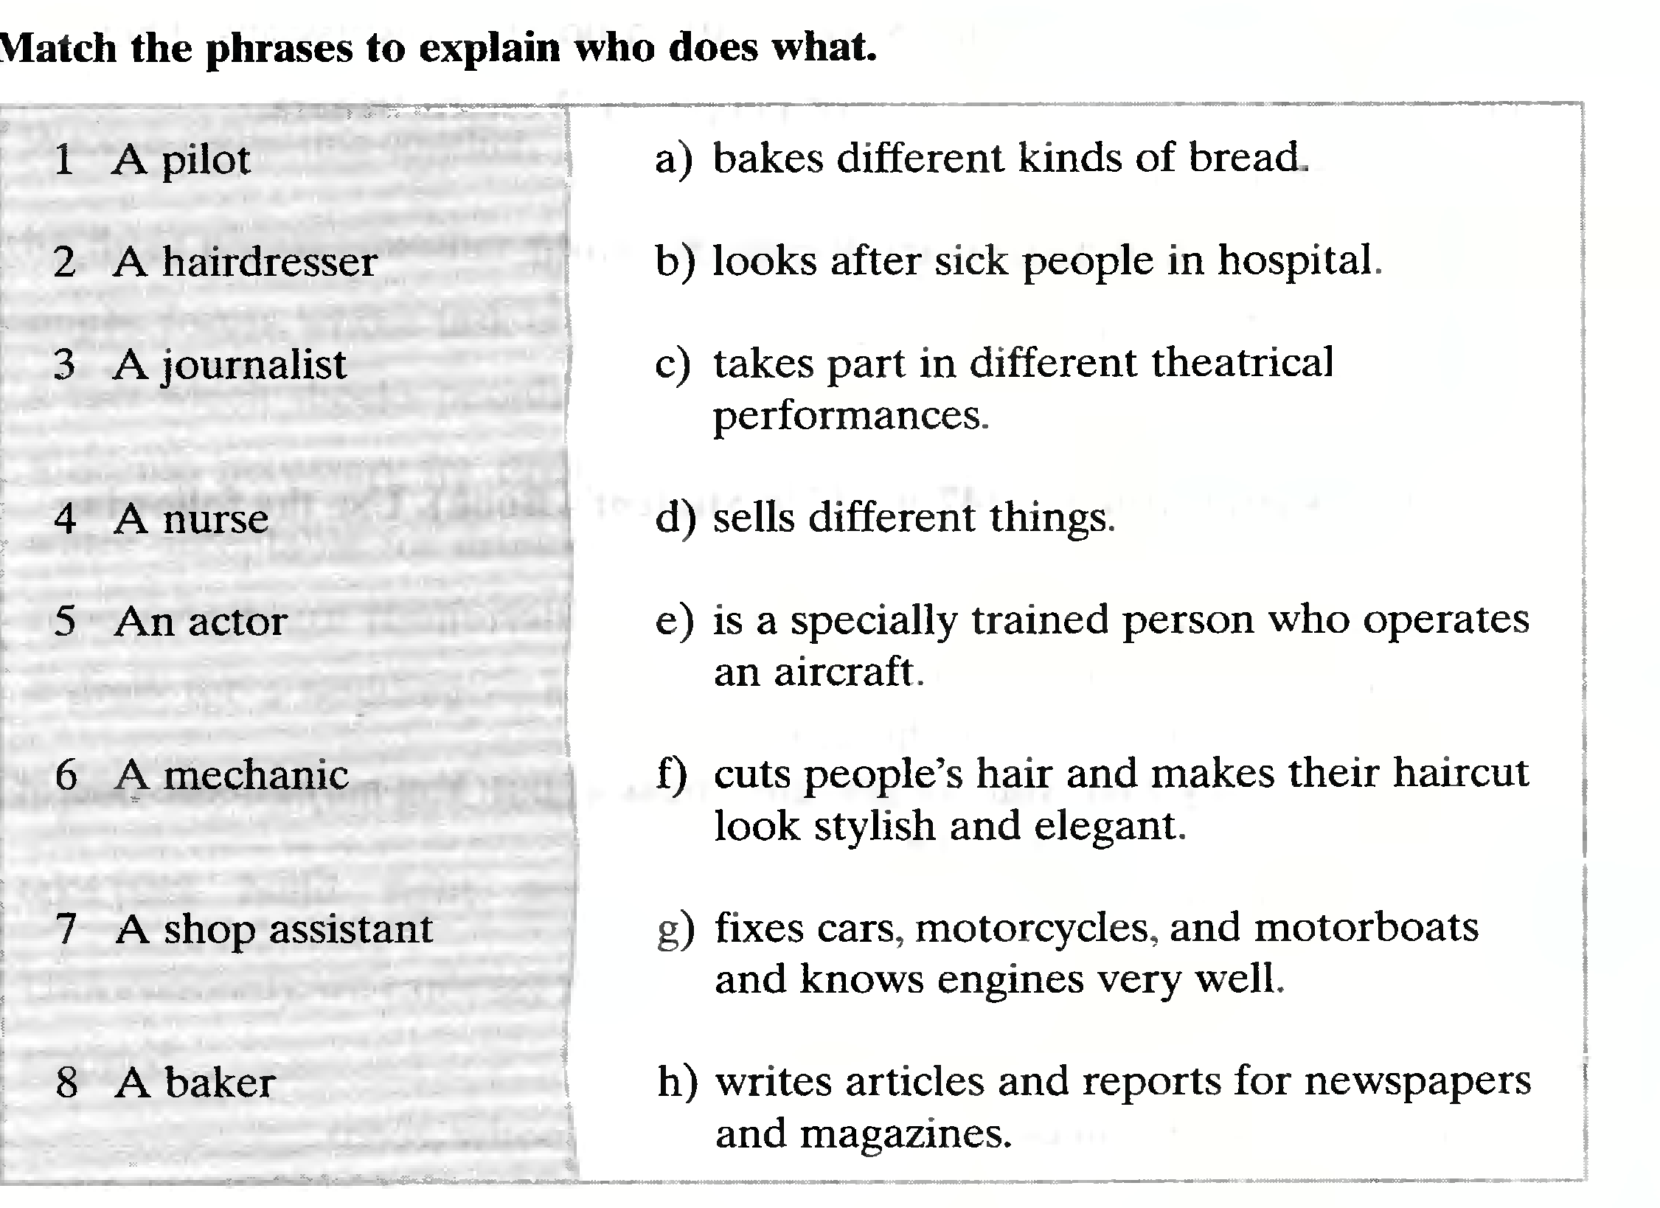
Task 2
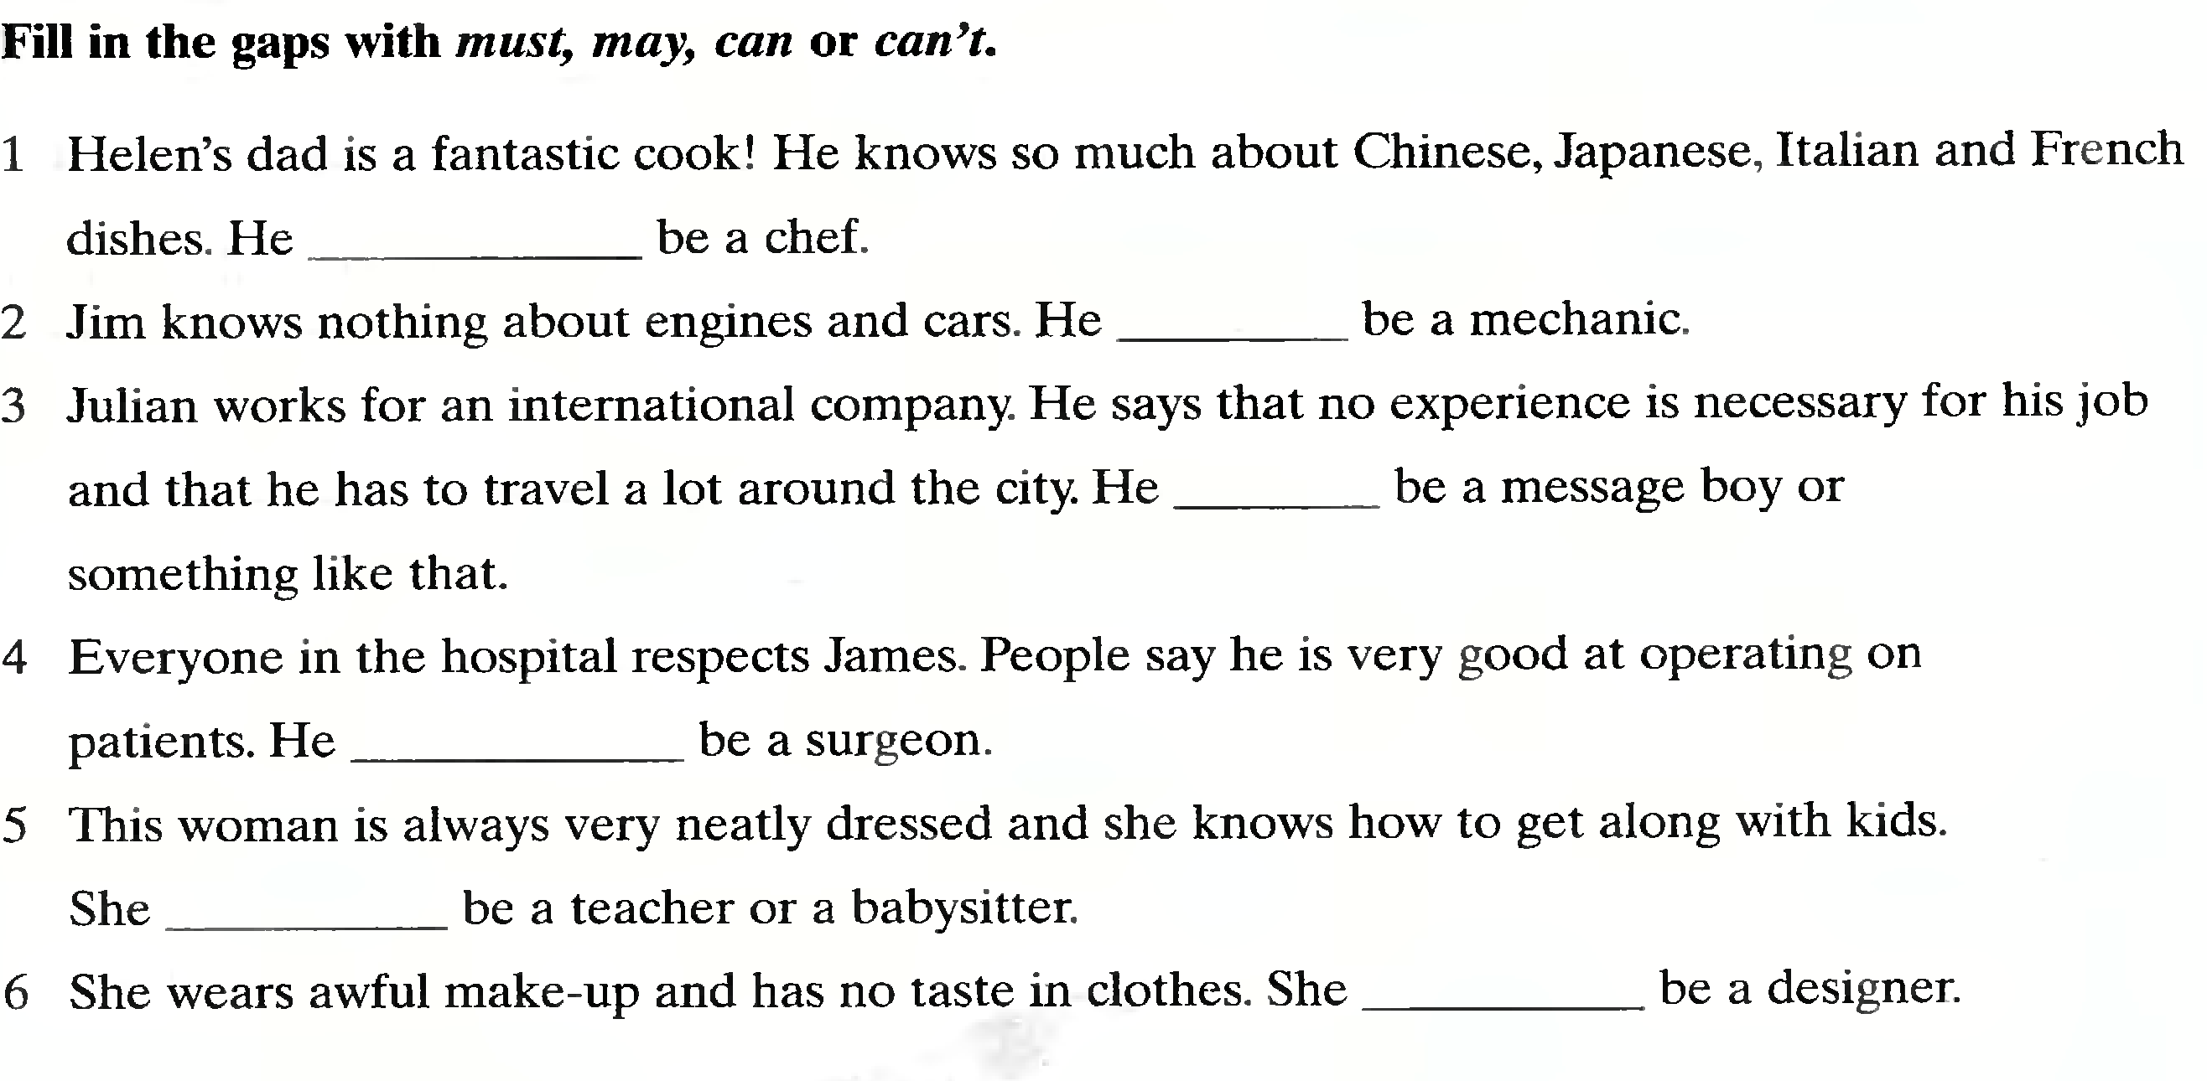

Task 3
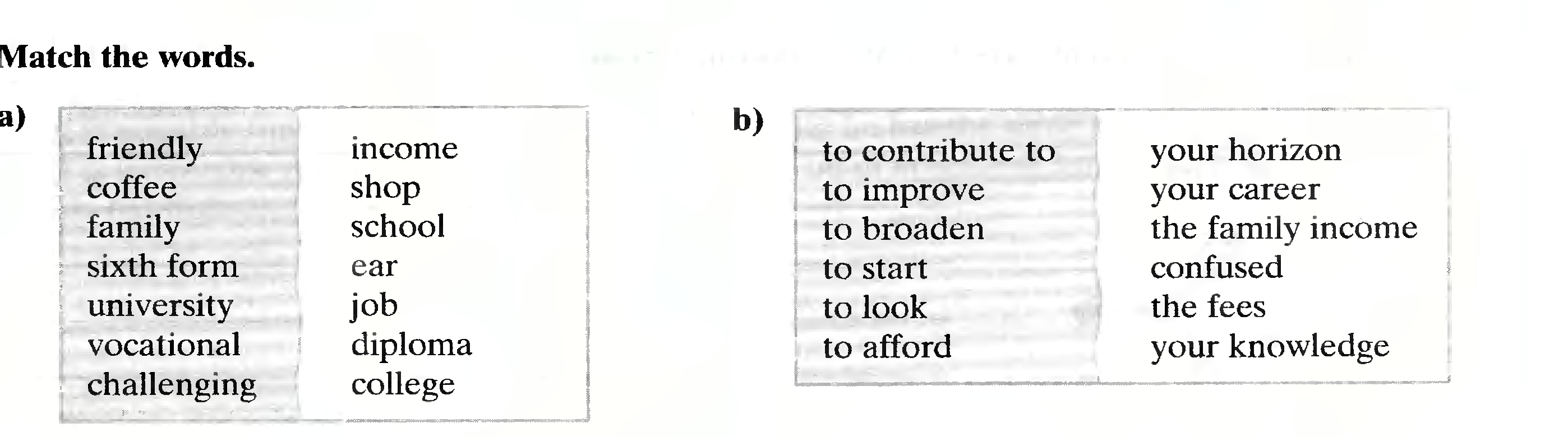
Task 4


