Blackpool Illuminations

Blackpool Illuminations run for 66 days each year. They switch on in late August with a star-studded 'Switch On' show and run to early November.
The 2006 Switch On was carried out by Dale Winton and the crowd were entertained by a host of acts including Peter Kay.David Tennant, a previous Doctor Who and past star of the Blackpool (television) television series, switched on the Lights in 2007. New for 2007 are a section outside the Tower called DecoDance, these were designed by Laurence Llewelyn-Bowen additionally new Doctor Whoilluminations have been erected outside the Dr Who exhibition.
At six miles (9.65 kilometres) long and using over one million bulbs, the Blackpool Illuminations are an awesome spectacle. The Blackpool Illuminations consist of a wide variety of light displays: lasers, neon, light bulbs, fibre optics, searchlights and floodlighting. In 2006, there were more than 500 scenic designs and features. There are set pieces made out of wood studded with light bulbs; the characters and objects portrayed seem to “move” by way of winking lights. Three-dimensional illuminated scenes are also popular. There are over 500 road features attached to lamp posts linked together with festoon lighting. Strings of lights along the structure of buildings pick out landmarks in luminous detail – you can always make out the Blackpool Tower and the Pleasure Beach Blackpool rides in this way.

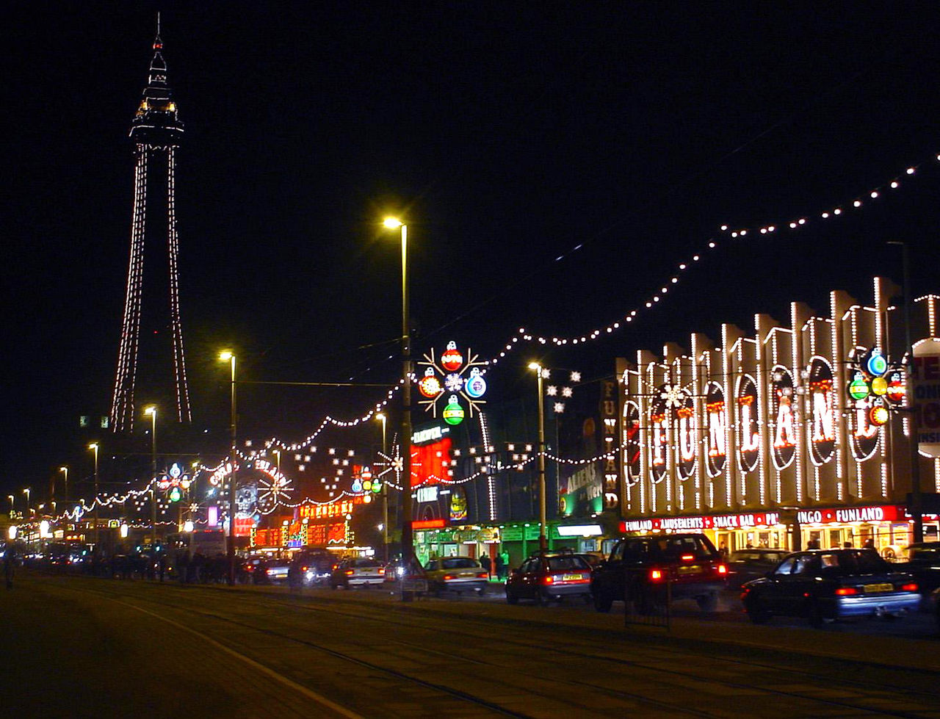
Illuminations on Blackpool promenade

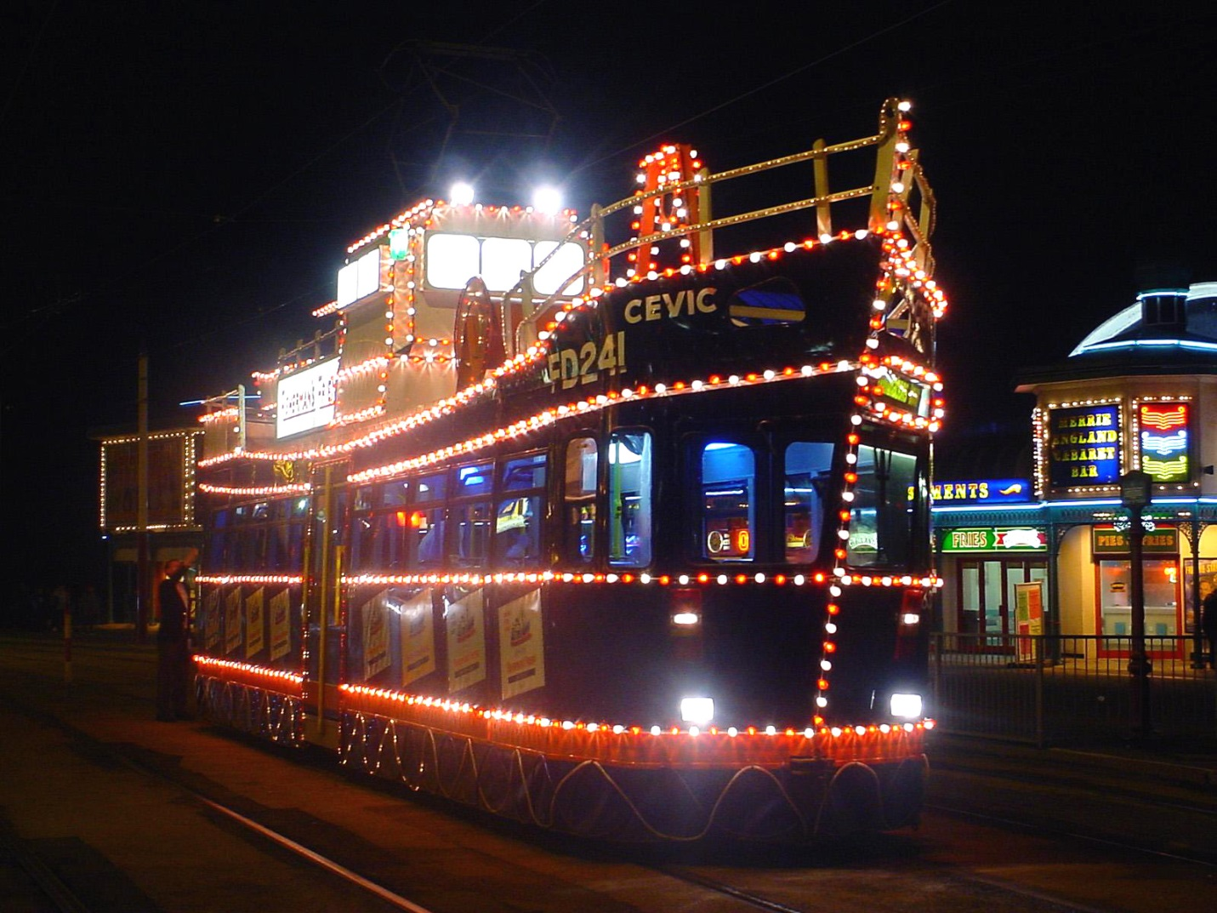

Illuminated trawler tram at Blackpool

Ben Nevis Race

The history of hill running on Ben Nevis dates back to 1895. William Swan, a barber from Fort William, made the first recorded timed ascent up the mountain on or around 27 September of that year, when he ran from the old post office in Fort William to the summit and back in 2 hours 41 minutes. The following years saw several improvements on Swan's record, but the first competitive race was held on 3 June 1898 under Scottish Amateur Athletic Association rules. Ten competitors ran the course, which started at the Lochiel Arms Hotel in Banavie and was thus longer than the route from Fort William; the winner was 21-year-old Hugh Kennedy, a gamekeeper at Tor Castle, who finished (coincidentally with Swan's original run) in 2 hours 41 minutes.
Regular races were organised until 1903, when two events were held; these were the last for 24 years, perhaps due to the closure of the summit observatory the following year.^{[18]} The first was from Achintee, at the foot of the Pony Track, and finished at the summit; It was won in just over an hour by Ewen MacKenzie, the observatory roadman. The second race ran from new Fort William post office, and MacKenzie lowered the record to 2 hours 10 minutes, a record he held for 34 years.
The Ben Nevis Race has been run in its current form since 1937. It now takes place on the first Saturday in September every year, with a maximum of 500 competitors taking part.^{[38]} It starts and finishes at the Claggan Park football ground on the outskirts of Fort William, and is 14 kilometres (8.7 mi) long with 1,340 metres (4,400 ft) of ascent.^{[39]} Due to the seriousness of the mountain environment, entry is restricted to those who have completed three hill races, and runners must carry waterproofs, a hat, gloves and a whistle; anyone who has not reached the summit after two hours is turned back.^{[40]} As of 2006 the records have stood unbroken since 1984, when Kenny Stuart and Pauline Howarth of Keswick Athletics Club won the men's and the women's races with times of 1:25:34 and 1:43:25 respectively.

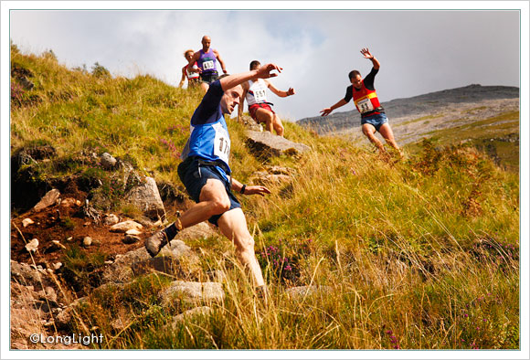

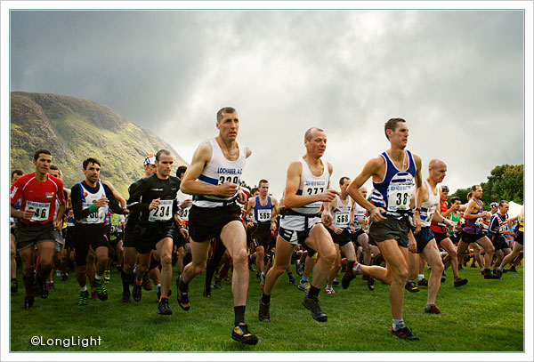

Trafalgar Day

Trafalgar Day is the celebration of the victory won by the Royal Navy, commanded by Vice-Admiral Horatio Nelson, over the combined French and Spanish fleets at the Battle of Trafalgar on 21 October 1805. The formation of the Navy League in 1894 gave added impetus to the movement to recognise Nelson's legacy, and grand celebrations were held in Trafalgar Square on Trafalgar Day, 1896.^{[1]} It was commemorated by parades, dinners and other events throughout much of the British Empire in the 19th century and early 20th century. It continues to be celebrated by navies of the Commonwealth of Nations.
Its public celebration declined after the end of World War I in 1918. The massive casualties and upheaval had changed the general public perception of war as a source of glorious victories to a more sombre view of it as a tragedy, for which the newly instituted Armistice Day on 11 November was created. However, Trafalgar Day was still marked as a public day each year. Around 1993, it was rumoured that John Major's government might make it a public holiday in place of May Day, and this plan has been revived in the 2011 Tourism Strategy created by the current coalition government.^{[3]}
The year 2005 was the bicentennial of the Battle of Trafalgar, and the Royal Navy led Trafalgar 200 celebrations. The 2005 International Fleet Review held off Spithead in the Solent on 28 June was the first since 1999 and the largest since Her Majesty The Queen's 1977 Silver Jubilee.

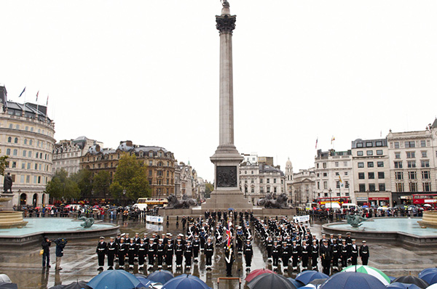

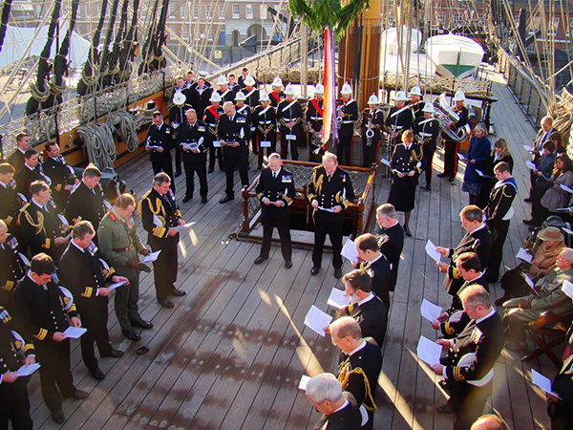

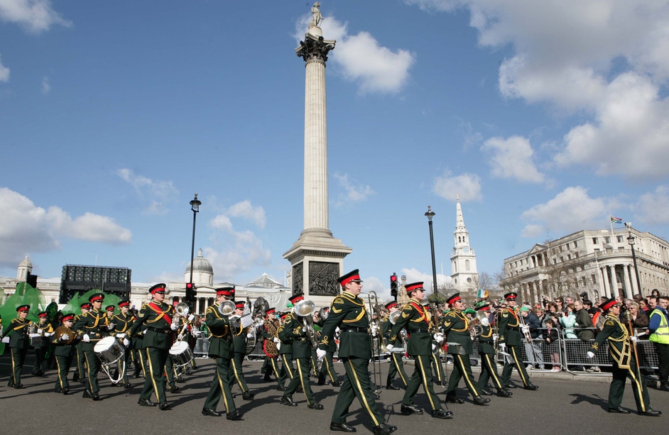

Apple Day

Apple Day is an annual celebration of apples and orchards, held in October. It is celebrated mainly in the United Kingdom. It traditionally falls on October 21, the date of the first such event in 1990, but events are held throughout the month. It is commonly a weekend event, usually taking place on the Saturday and Sunday closest to 30 October.
Apple Day events can be large or small, from apple games in a garden to large village fairs with cookery demonstrations, games, apple identification, juice and cider, gardening advice, and the sale of many hundreds of apple varieties.
Apple Day was initiated by Common Ground on 21 October 1990 at an event in Covent Garden, London, and has been celebrated in each subsequent year. By 2000 the day was celebrated in more than 600 events around the United Kingdom. Common Ground describe the day as a way of celebrating and demonstrating that variety and richness matter to a locality and that it is possible to effect change in your place. Common Ground has used the apple as a symbol of the physical, cultural and genetic diversity we should not let slip away. In linking particular apples with their place of origin, they hope that orchards will be recognized and conserved for their contribution to local distinctiveness, including the rich diversity of wild life they support.

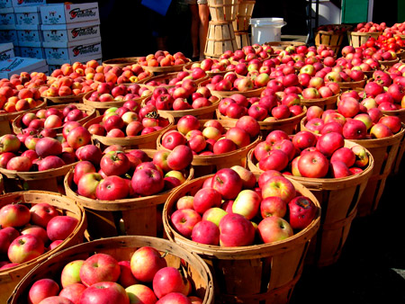

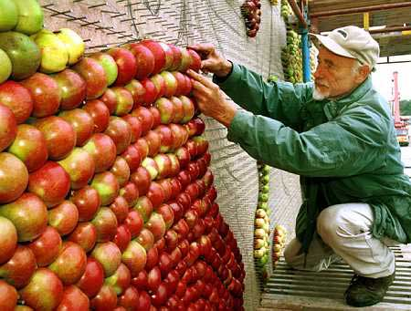

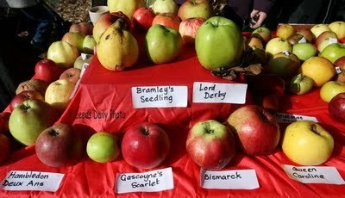
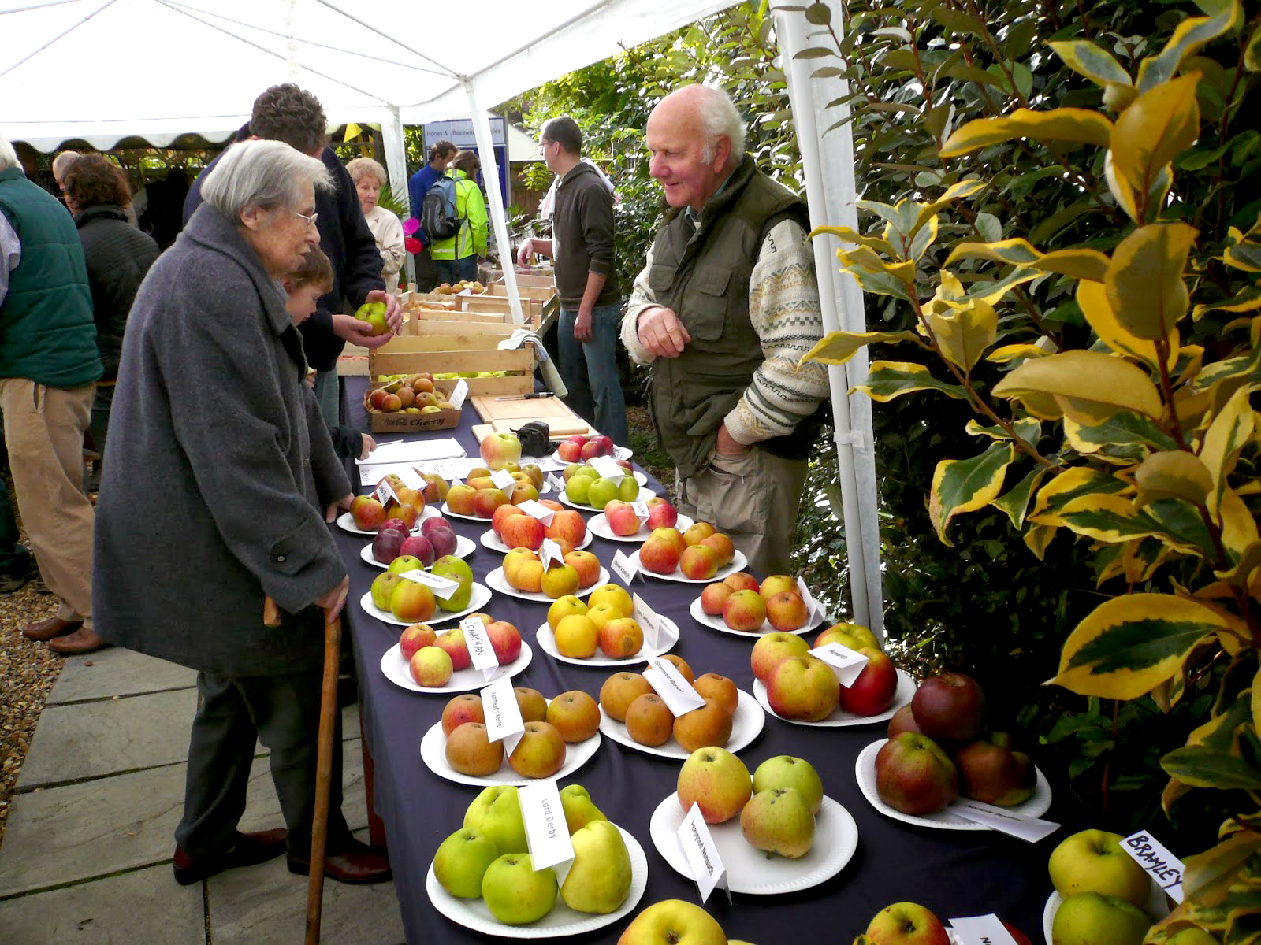

State Opening of Parliament

The State Opening of Parliament is an event in the United Kingdom that marks the commencement of a session of the Parliament of the United Kingdom and includes a Speech from the Throne, known as the Queen's (or King's) Speech. The State Opening is an extremely elaborate ceremony showcasing British history, culture, and contemporary politics.
The State Opening takes place in the House of Lords Chamber and, before 2011, was usually held in November or December or, in a general election year, when the new Parliament first assembled. In 1974, when two general elections were held, there were two State Openings.
With the introduction in 2011 of fixed-term parliaments of five years in length, the State Opening has been held in May or June. Parliamentary elections are held in the May of every year divisible by five, most recently in 2015. The 2012 ceremony took place on 9 May; subsequent ceremonies took place on 8 May 2013, 4 June 2014, and 27 May 2015. The State Opening may be held at other times of the year if Parliament dissolves due to a vote of no confidence.
The current Sovereign, Queen Elizabeth II, has opened every session of the Westminster Parliament since her accession, except in 1959 and 1963, when she was pregnant with Prince Andrew and Prince Edward, respectively. These two sessions were opened by Lords Commissioners, headed by the Archbishop of Canterbury (Geoffrey Fisherin 1959, and Michael Ramsey in 1963), empowered by Her Majesty. The Lord Chancellor (The Viscount Kilmuir in 1959, The Lord Dilhorne in 1963) read the Queen's Speech on those occasions.

Searching of the cellars
First, the cellars of the Palace of Westminster are searched by the Yeomen of the Guard in order to prevent a modern-day Gunpowder Plot. The Plot of 1605 involved a failed attempt by English Catholics to blow up the Houses of Parliament and kill the Protestant King James I and aristocracy. Since that year, the cellars have been searched, now largely, but not only, for ceremonial purposes.

Assembly of Peers and Commons
The peers assemble in the House of Lords wearing their robes. They are joined by senior representatives of the judiciary and members of the diplomatic corps. The Commons assemble in their own chamber, wearing ordinary day dress, and begin the day, as any other, with prayers.

Delivery of Parliamentary hostage
Before the monarch departs Buckingham Palace the Treasurer, Comptroller and Vice-Chamberlain of the Queen's Household (all of whom are Government whips) deliver ceremonial white staves to her. The Queen keeps the Vice-Chamberlain 'prisoner' for the duration of the state opening as insurance for the safe return of the monarch, though he is well entertained until the successful conclusion of the ceremony, when he is released. The Vice-Chamberlain's imprisonment is now purely ceremonial, though he does remain under guard; originally, it guaranteed the safety of the Sovereign as he or she entered a possibly hostile Parliament. The tradition stems from the time of Charles I, who had a contentious relationship with Parliament and was eventually beheaded in 1649 during the Civil War between the monarchy and Parliament. A copy of Charles I's death warrant is displayed in the robing room used by the Queen as a ceremonial reminder of what can happen to a Monarch who attempts to interfere with Parliament.

Arrival of Royal Regalia
Before the arrival of the sovereign, the Imperial State Crown is carried to the Palace of Westminster in its own State Coach. From the Victoria Tower, the Crown is passed by the Queen's Bargemaster to the Comptroller of the Lord Chamberlain's office. It is then carried, along with the Great Sword of State and the Cap of Maintenance, to be displayed in the Royal Gallery.

Arrival of the Sovereign and assembly of Parliament
The Queen arrives from Buckingham Palace at the Palace of Westminster in a horse-drawn coach, entering through the Sovereign's Entrance under the Victoria Tower; she is accompanied by her consort The Duke of Edinburgh (though their son The Prince of Wales has deputised for his father) and sometimes by other members of the royal family, such as The Prince of Wales and The Duchess of Cornwall or The Princess Royal. Traditionally, members of the armed forces line the procession route from Buckingham Palace to the Palace of Westminster. The Royal Standard is hoisted to replace the Union Flag upon the Sovereign's entrance and remains flying whilst she is in attendance. Then, after she takes on the Parliament Robe of State and Imperial State Crown in the Robing Chamber, the Queen proceeds through the Royal Gallery to the House of Lords, usually accompanied by the Duke of Edinburgh and immediately preceded by the Earl Marshal, and by one peer (usually the Leader of the House of Lords) carrying the Cap of Maintenance on a white rod, and another peer (generally a retired senior military officer) carrying the Great Sword of State, all following the Lord Great Chamberlain and his white stick, commonly the practical implement of ceremonial ushers, raised aloft. Once seated on the throne, the Queen, wearing the Imperial State Crown, instructs the House by saying, "My Lords, pray be seated."; her consort takes his seat on the throne to her left and other members of the Royal family may be seated elsewhere on the dais (for instance the Prince of Wales and Duchess of Cornwall are seated on thrones on a lower portion of the dais to Her Majesty's right.)

Procession of the Commons
The Speaker proceeds to attend the summons at once. The Serjeant-at-Arms picks up the ceremonial mace and, with the Speaker and Black Rod, leads the Members of the House of Commons as they walk, in pairs, towards the House of Lords. By custom, the members saunter, with much discussion and joking, rather than formally process. The Prime Minister and the Leader of the Opposition followed by The Deputy Prime Minister and the Deputy Leader of the Opposition usually walk side by side, leading the two lines of MPs. The Commons then arrive at the Bar of the House of Lords where they bow to The Queen. No person who is not a member of the Upper House may pass the Bar unbidden when it is in session; a similar rule applies to the Commons. They remain standing at the Bar during the speech.

Delivery of the scroll
The Queen reads a prepared speech, known as the "Speech from the Throne" or the "Queen's Speech", outlining the Government's agenda for the coming year. The speech is written by the Prime Minister and his cabinet members, and reflects the legislative agenda for which the Government seeks the agreement of both Houses of Parliament. It is traditionally written on goatskin vellum, and presented on bended knee for Her Majesty to read by the Lord Chancellor, who produces the scroll from a satchell-like bag. Traditionally, rather than turning his back on Her Majesty, which might appear disrespectful, The Lord Chancellor walks backwards down the steps of the throne, continuing to face the monarch. Lord Irvine of Lairg, the Lord Chancellor appointed by Prime Minister Tony Blair, sought to break the custom and applied successfully for permission to turn his back on The Queen and walk down the steps forwards, but the next Lord Chancellor Jack Straw continued the former tradition.

Delivery of the speech
The whole speech is addressed to "My Lords and Members of the House of Commons", with one significant exception that Her Majesty says specifically, "Members of the House of Commons, estimates for the public services will be laid before you", since the Budget is constitutionally reserved to the Commons.
The Queen reads the entire speech in a neutral and formal tone, implying neither approval nor disapproval of the proposals of Her Majesty's Government: the Queen makes constant reference to "My Government" when reading the text. After listing the main bills to be introduced during the session, the Queen states: "other measures will be laid before you", thus leaving the Government scope to introduce bills not mentioned in the speech. The Queen mentions any State Visits that she intends to make and also any planned State Visits of foreign Heads of State to the United Kingdom during the Parliamentary session. The Queen concludes the speech in saying:
"My Lords and Members of the House of Commons, I pray that the blessing of Almighty God may rest upon your counsels".
Traditionally, the members of both Houses of Parliament listen to the Queen's Speech respectfully, neither applauding nor showing dissent towards the speech's contents before it is debated in each House. This silence, however, was broken in 1998, when the Queen announced the Government's plan of abolishing the right of hereditary peers to sit in the House of Lords. A few Labour members of the House of Commons cried "yes" and "hear", prompting several of the Lords to shout "no" and "shame". The Queen continued delivering her speech without any pause, ignoring the intervention. The conduct of those who interrupted the speech was highly criticised at the time.

Departure of monarch
Following the speech, the Queen leaves the chamber before the Commons bow again and return to their Chamber.

Debate on the speech
After the departure of the Queen, each Chamber proceeds to the consideration of an "Address in Reply to Her Majesty's Gracious Speech." But first, each House considers a bill pro forma to symbolise their right to deliberate independently of the monarch. In the House of Lords, the bill is called the Select Vestries Bill, while the Commons equivalent is the Outlawries Bill. The Bills are considered for the sake of ceremony only, and do not make any actual legislative progress. The first speech of the debate in the Commons is, by tradition, a humorous one given by a member selected in advance. The consideration of the address in reply to the Throne Speech is the occasion for a debate on the Government's agenda. The debate on the Address in Reply is spread over several days. On each day, a different topic, such as foreign affairs or finance, is considered. The debate provides an indication of the views of Parliament regarding the government's agenda.

